ECE 390 Lecture Notes 2

# Project Management

Project management consists of:

* Planning the project
* Organizing the necessary resources
* Leading the individuals responsible for carrying out the project
* Monitoring project progress
* Implementing project deliverable
* Project sponsor: person/people who have the resources to complete the project; they lead the process of developing the project charter document
* Project manager: the person assigned to fulfill the project objectives

## Project Lifecycle

* Initial Stage
  + Nature and scope of project are defined and documented in **project charter**:
    - Background
    - Methodology
    - Justification
    - Requirements
    - Constraints
    - Assumptions
    - Risk
    - Deliverable
* Planning Stage
  + Estimate time, cost, and resources needed to complete the project described in the project charter
  + Project is broken down into smaller modules, detailed in **project plan**:
    - Project scope
    - Project team
    - Work breakdown structure
    - Project schedule
    - Risk plan
    - Communication plan
    - Budget
* Execution Stage
  + Work is carried out to deliver the project defined in the project charter and detailed in the project plan
* Monitoring and Control Stage
  + Takes place throughout execution stage
    - Reviewing project activities
    - Monitoring project constraints
    - Identifying corrective actions
    - Implementing changes
* Closure Stage
  + Occurs when all activities defined in the project charter are complete
  + **Project closure report** is prepared to document the closure of the project

# Project Management Tools

Tools that provide the project manager guidance as to what issues need to be addressed at each stage of the project

## Work Breakdown Structure (WBS)

* Multi-level system that consists of tasks, subtasks, and work packages
* **Work packages** are the smallest unit – it defines the work in sufficient detail such that it can be measured, budgeted, scheduled, and controlled
* WBS is represented as:
  + Organizing Chart: topmost layer represents project as a whole; successive layers below represent finer level of details
  + Indented List: each successive layer is indented from the layer above

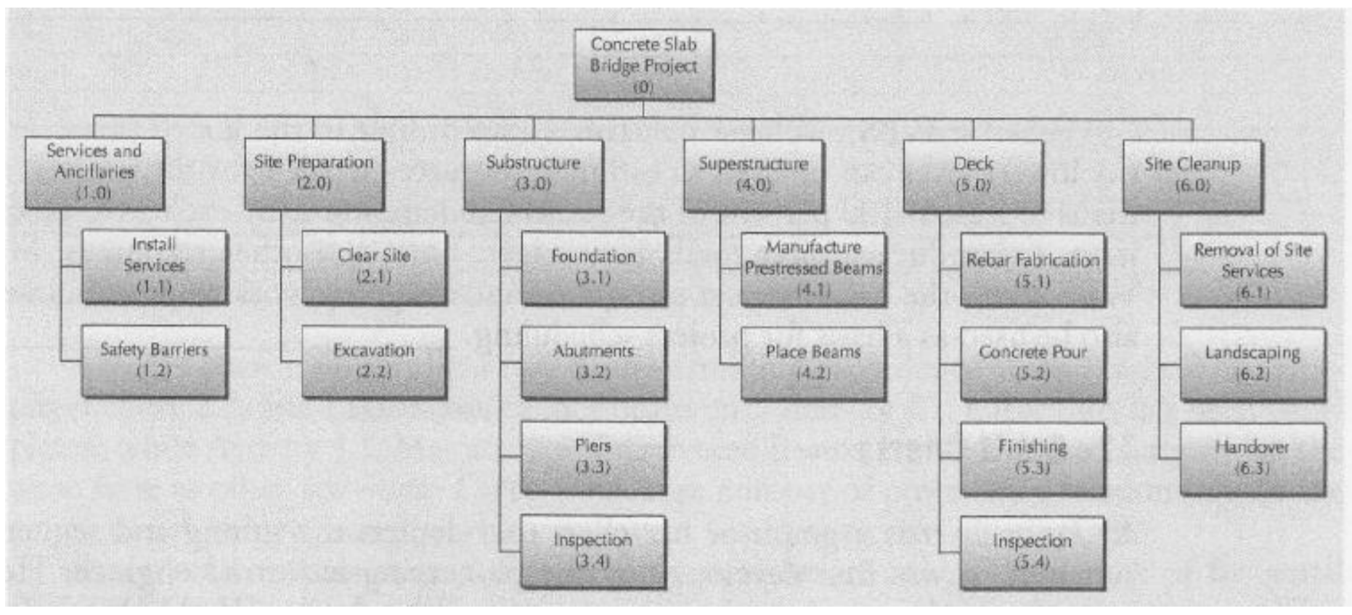

**Example**: Develop precedence relations chart for ABC Computers

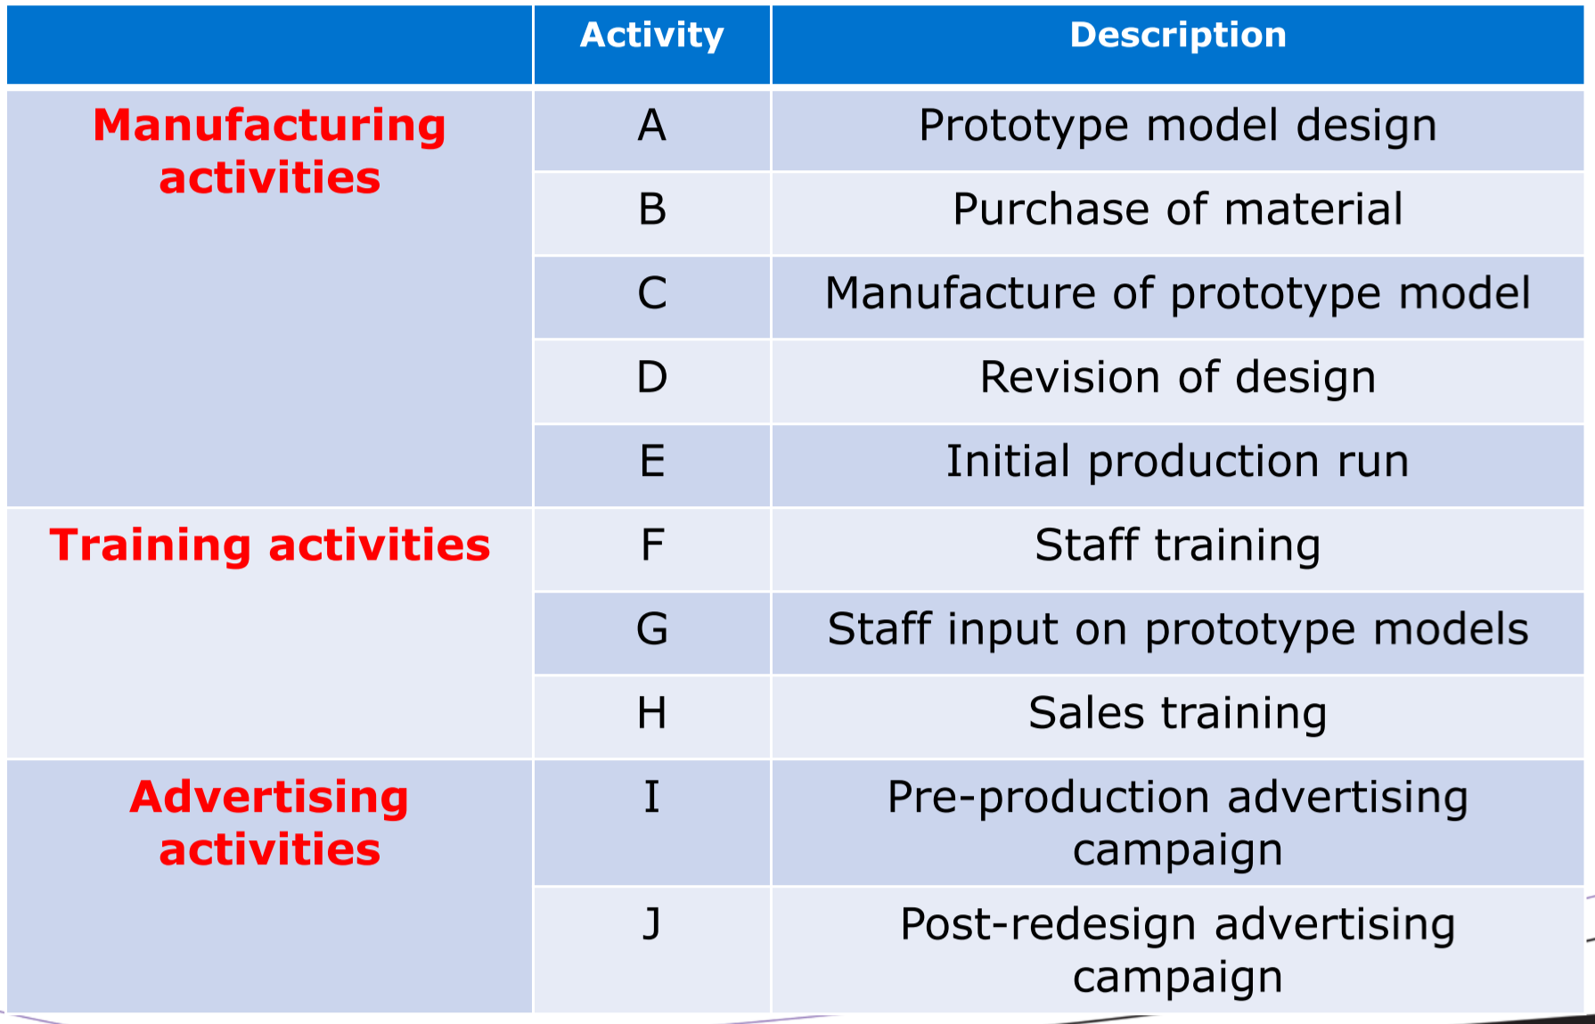

Precedence relationship chart:

|  |  |  |
| --- | --- | --- |
| **Activity** | **Immediate Predecessor** | **Estimated Completion Time** |
| A | None | 90 |
| B | A | 15 |
| C | B | 5 |
| D | G | 20 |
| E | D | 21 |
| F | A | 25 |
| G | C, F | 14 |
| H | D | 18 |
| I | A | 30 |
| J | D, I | 45 |

## Gantt Chart

* Graph or bar chart that depicts timing and sequence of project activities – used to monitor and control project progress
  + Horizontal axis: time
  + Vertical axis: activities
  + Draw horizontal bars proportionate to expected project completion time
* In an **earliest-time** Gantt chart, each bar begins and ends at the earliest possible start/finish time of the activity
* Makes it easy for PM to see if project is progressing on schedule
* Advantages:
  + Easy to construct
  + Provides schedule of earliest completion dates of activities
* Disadvantages:
  + Gives only one possible schedule – earliest
  + Doesn’t show whether or not project is behind schedule
  + Doesn’t demonstrate effect of delays on any activities

## Critical Path Method (CPM)

* **Network analysis**: set of techniques used for planning, management, and control of projects
* Emphasis of Critical Path Method (CPM): trade-off between project cost and overall completion time
  + E.g. For certain projects, may be possible to decrease completion time by spending more money
* Emphasis of Project Evaluation and Review Techniques (PERT): complete program in shortest possible time
  + Has ability to cope with uncertain activity completion times
  + E.g. For a particular activity, mostly likely completion is 4 weeks, but can be anywhere from 3-8 weeks

## The Project Network

* **Arrows 🡪**: indicates activity, time-consuming effort needed to perform a part of the work
* **Nodes •**: indicates event, a point in time where one/more activities start and/or finish
* Two representations:
  + Activity on Arc (AOA): arcs = activities, nodes = relationships between activities



* + Activity on Node (AON): nodes = activities, arcs = relationships between activities
    - E.g. two concurrent activities that can start after a common predecessor is completed, are represented by two arcs coming out of predecessor
    - Used in modern practice – more natural way to represent activities

**Example**: Draw the AOA and AON for a project with 6 activities:

* Activity 1 precedes Activities 2 and 3
* Activity 4 follows Activity 2
* Activities 4 and 5 must be completed prior to the start of Activity 6

**AOA**:

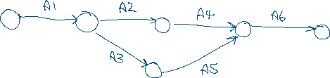

**AON**:

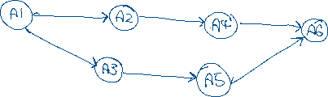

**Example**: Develop a CPM network for the project described below:

RFP = Request for Proposal

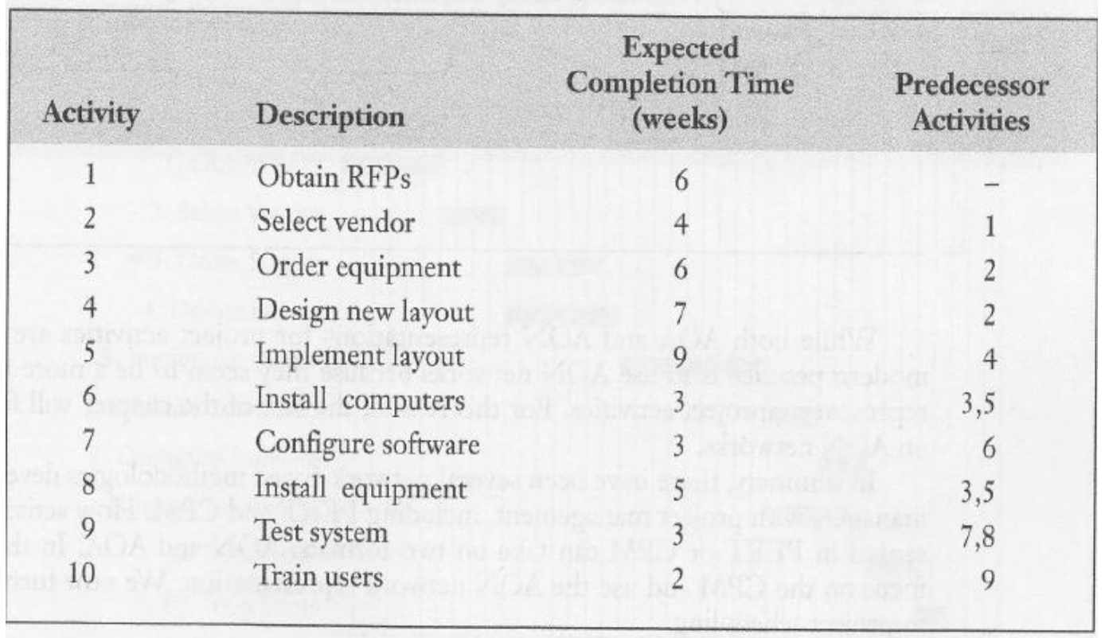

**AOA**:

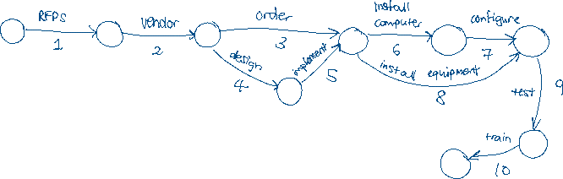

**AON**:

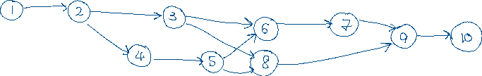

## Project Scheduling

* **Project**: collection of tasks that must be completed in minimum time or minimum cost
* Objective of project scheduling:
  + Complete the project as early as possible
  + Calculate likelihood of project completing within a certain period
  + Finding minimum cost schedule for project to complete by a certain date
  + Investigate the result of delays in activity’s completion time
  + Progress control
  + Smooth out resource allocation over project duration

### Task Designate

* Tasks are called **activities**
  + Estimated completion time and costs associated with each activity
  + Activity completion time is related to amount of resources committed to it
  + Degree of activity detail depends on the application and specificity of data
* To determine optimal schedules:
  + Identify all project activities
  + Determine precedence relations between activities

## Critical Path Method (CPM)

* Activities are shown as network of precedence relationships using AON
  + Single estimate of activity time
  + Deterministic activity times
* Generally used for repetitive jobs where activity completion time can be predicted with considerable certainty based on past experience

## Project Evaluation and Review Techniques (PERT)

* Activities are shown as network of precedence relationships using AOA
  + Multiple time estimates
  + Probabilistic activity times
* Generally used for non-repetitive jobs (e.g. research and development work) where time and cost estimates are uncertain

## CPM and PERT

* Benefits:
  + Useful at many stages of project management
  + Mathematically simple
  + Gives critical path and slack time
  + Provides project documentation
  + Helps monitor costs
* Questions addressed:
  + Project completion time?
  + Is project on schedule / within budget?
  + What are the critical activities?
  + How can project be finished early with least cost?
* Critical path: set of activities that must be completed exactly as planned in order to keep project on schedule
  + Longest path in the network – set of activities that connect the start and finish nodes, with no slack
  + A delay in any activity on the critical path will result in a delay in project completion
  + The sum of activity completion times on the critical path is the project’s **minimal completion time**

Example:

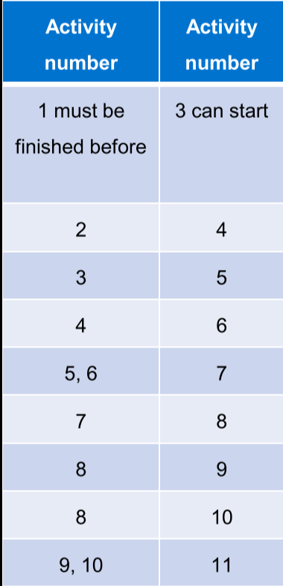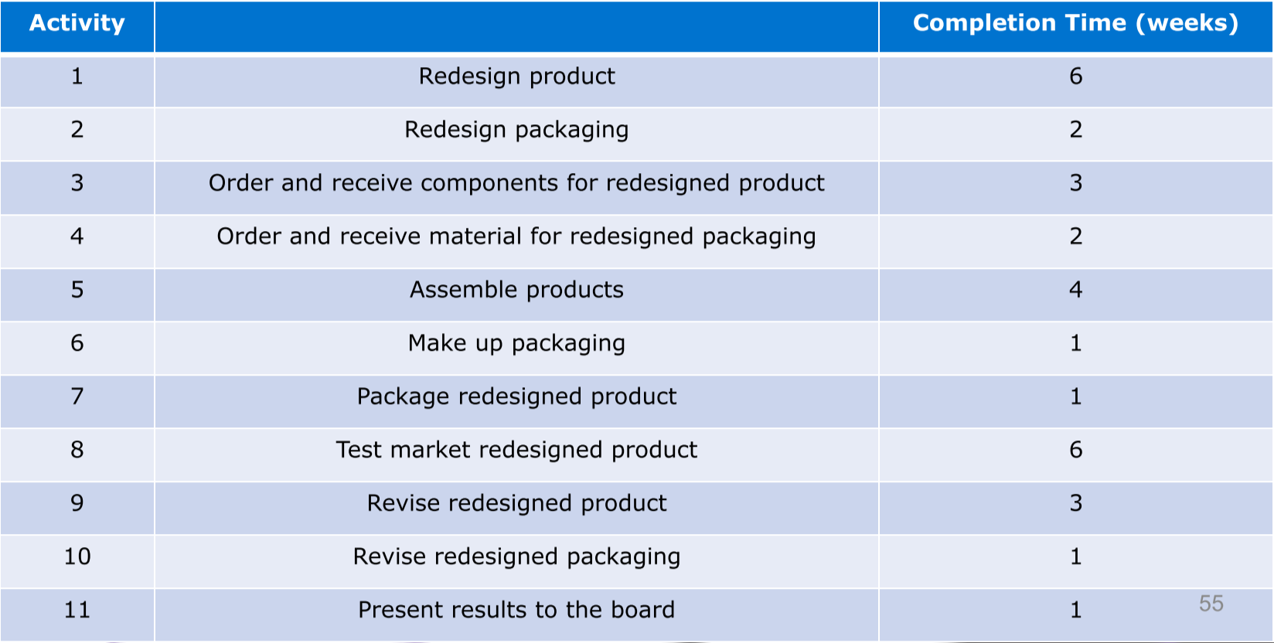

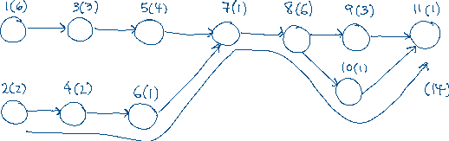

Example:

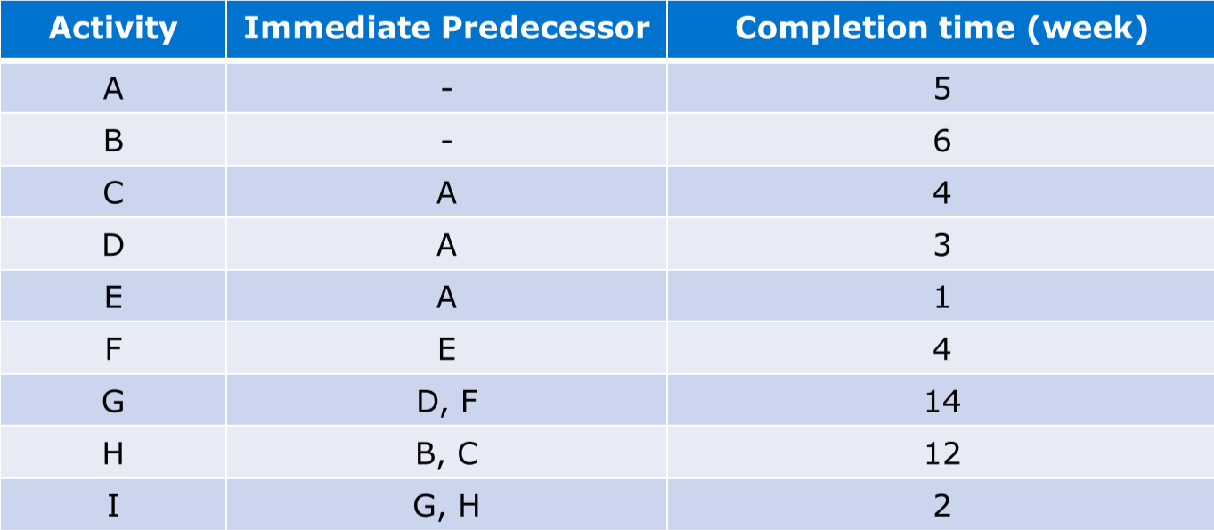

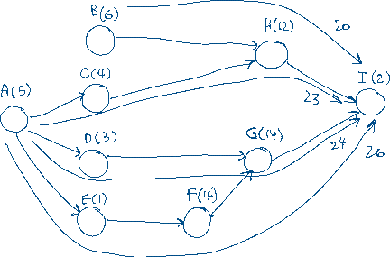

* Finding the critical path involves two passes through the CPM network graph:
  1. Determine earliest possible start and finish times for each activity – earliest feasible time for completing the project
  2. Network goes in reverse, starting with completion time established in first pass, and computing the least time each activity can start and finish; this identifies activities that can start and finish later than the dates found in the first project, without delaying the project
* Activities that have the same earliest and latest start time, are on the critical path
* In order to keep track of times, some additional notations:
  + **t** – duration of activity
  + **ES** – earliest start time; equal to the latest EF of nodes entering it
  + **EF** – earliest finish time; EF = ES + t
  + **LS** – latest start time
    - For all activities that immediately precede finish node, LS = minimal project completion time
    - For all others, LS = LF - t
  + **LF** – latest finish time
    - For all activities that immediately precede finish node, LF = LS – t
    - For all others, LF = min(LS) of immediate successors

Example: Forward pass [ES, EF]

D [5, 8]

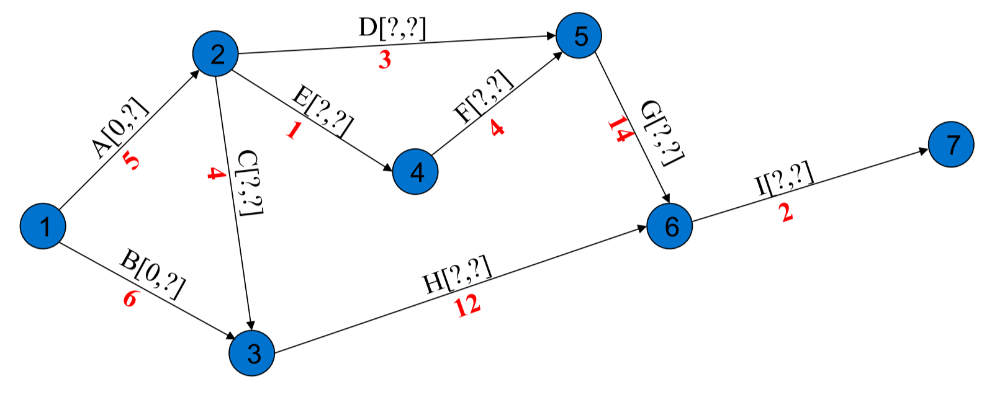

B [0, 6]

G [10, 24]

I [24, 26]

H [9, 21]

E [5, 6]

F [6, 10]

C [5, 9]

A [0, 5]

Example: Backward pass [LS, LF]

D [5, 8]  
3 [7, 10]



H [9, 21]  
12 [12, 24]

I [24, 26]  
2[24, 26]

F [6, 10]  
4 [6, 10]

G [10, 24]  
14 [10, 24]

A [0,5]  
5 [0, 5]

B [0, 6]  
6 [6, 12]

C [5, 9]  
4 [8, 12]

E [5, 6]  
1 [5, 6]

### Slack Time

* Activity start and completion times can be delayed by planned or unforeseen reasons
  + Some delays may affect project completion time
* **Slack time** is the time an activity can be delayed without delaying the project completion date, assuming no other delays take place in the project
 $$Slack=LS-ES=LF-EF$$

 + E.g. Activity C can be delayed by up to 3 weeks – can start anywhere between week 5 and week 8
* Critical path activities have zero slack time
  + If any critical path activity is shortened/extended, project time will be shortened/extended

Example:

|  |  |
| --- | --- |
| **Activity** | **Slack Time** |
| A | 0 |
| B | 6 |
| C | 3 |
| D | 2 |
| E | 0 |
| F | 0 |
| G | 0 |
| H | 3 |
| I | 0 |

* Effort should be made to control critical path activities, in order for project to meet due date
  + If resources can be spent to speed up activities, focus on ones in the critical path
  + If resources can be saved by lengthening some activities, do so for non-critical activities (up until slack time)

### Delays

* Delays in **critical activities** cause the entire project to be delayed by the same amount
* Delays in **non-critical activities** cause the project to be delayed by $delay-slack time$

# Engineering Design Standards

## Standards

* Published documents establishing specifications and procedures
* Establishes consistent protocols that can be universally understood and adopted
* Makes it easier to understand and compare competing products
* Assures interconnectivity and interoperability requirements are met
* **Code**: laws or regulations that specify minimum standards to protect public health/safety
* **Specification**: set of conditions and requirements of precise and limited application that provide a detailed description
* **Technical regulation**: mandatory government requirements that define characteristics and/or the performance requirements of a product, service, or process

### Governing Bodies

* **International Electrotechnical Commission (IEC)**
  + Global organization publishing consensus-based international standards
* **Institute of Electrical and Electronic Engineers (IEEE)**
  + Technical publishing, technical conferences, and development of technical standards
* **American National Standards Institute (ANSI)**
  + Private, non-profit membership society that ensures single set of non-conflicting American standards is developed
* **Canadian Standards Association (CSA)**
  + Non-profit standards organization that develops standards for 57 areas
* **Professional Engineers Ontario (PEO)**
  + Regulates professional engineering and governs individuals and organizations that the PEO licenses
* **National Fire Protection Association (NFPA)**
  + Well-recognized set of voluntary consensus codes and standards used in fire service, industrial, health care, building code, and others

# Uncertainty and Risk

* Failure: inability of system, subsystem, or component to perform required function
* Quality assurance: probability that system, subsystem, or component will perform its intended function when tested
* Reliability: probability that system, subsystem, or component will perform its intended function for a specified period of time or under normal conditions
* Risk: combination of probability of an abnormal event or failure, and the consequences of that event
* **Risk assessment**: identifying, characterizing, quantifying, and evaluating risks and their significance
* **Risk management**: any technique used to minimize the probability of an event or mitigate its consequences
* **Uncertainty**: measure the knowledge limits in a technical area, expressed as a probability distribution around a point estimate
  + Statistical confidence
  + Tolerance
  + Incompleteness/inaccuracy of input data
  + Problem modelling ambiguity

## Sensitivity Analysis and Sensitivity Graphs

* To what extent do the variations in data affect the decision?
  + When a small variation in a particular estimate would change the alternative selected, the decision is **sensitive** to the estimate
* Sensitivity analysis evaluates the impact of any project parameter, by determining the amount of variation necessary to affect a change in outcome
* Sensitivity graphs assess the effect of one-at-a-time changes in key parameter values of a project on an economic performance measure
  + Graphs consist of:
    - **Base case**: estimated parameter values are used to calculate PW, AW, or IRR of project
    - **Change in performance curve**: parameter is varied above and below base case, while fixing all other parameters

Example: What is the present worth of the incremental investment in the cogeneration plant? What is the impact of a 5% and 10% increase and decrease in each of the parameters of the problem? MARR = 12%.

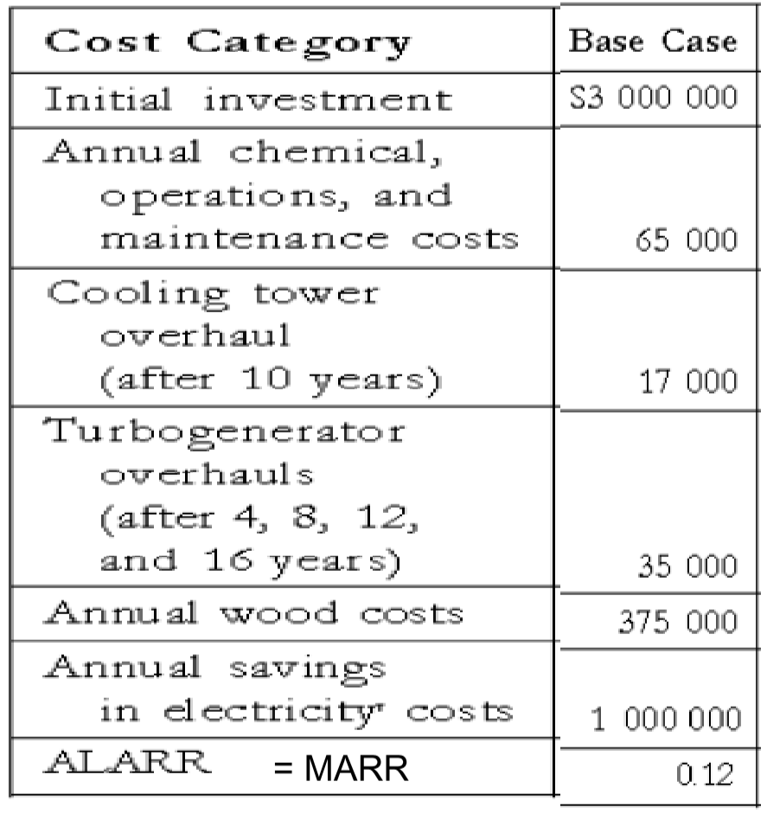

$$PW=-3,000,000-(65,000+375,000-1,000,000) (P/A,12\%,20)-17,000(P/F,12\%,10)-35,000[(P/F,12\%,4)+(P/F,12\%,8)+(P/F,12\%,12)+(P/F,12\%,16)] \\ =1,126,343$$

Repeat for all combinations:

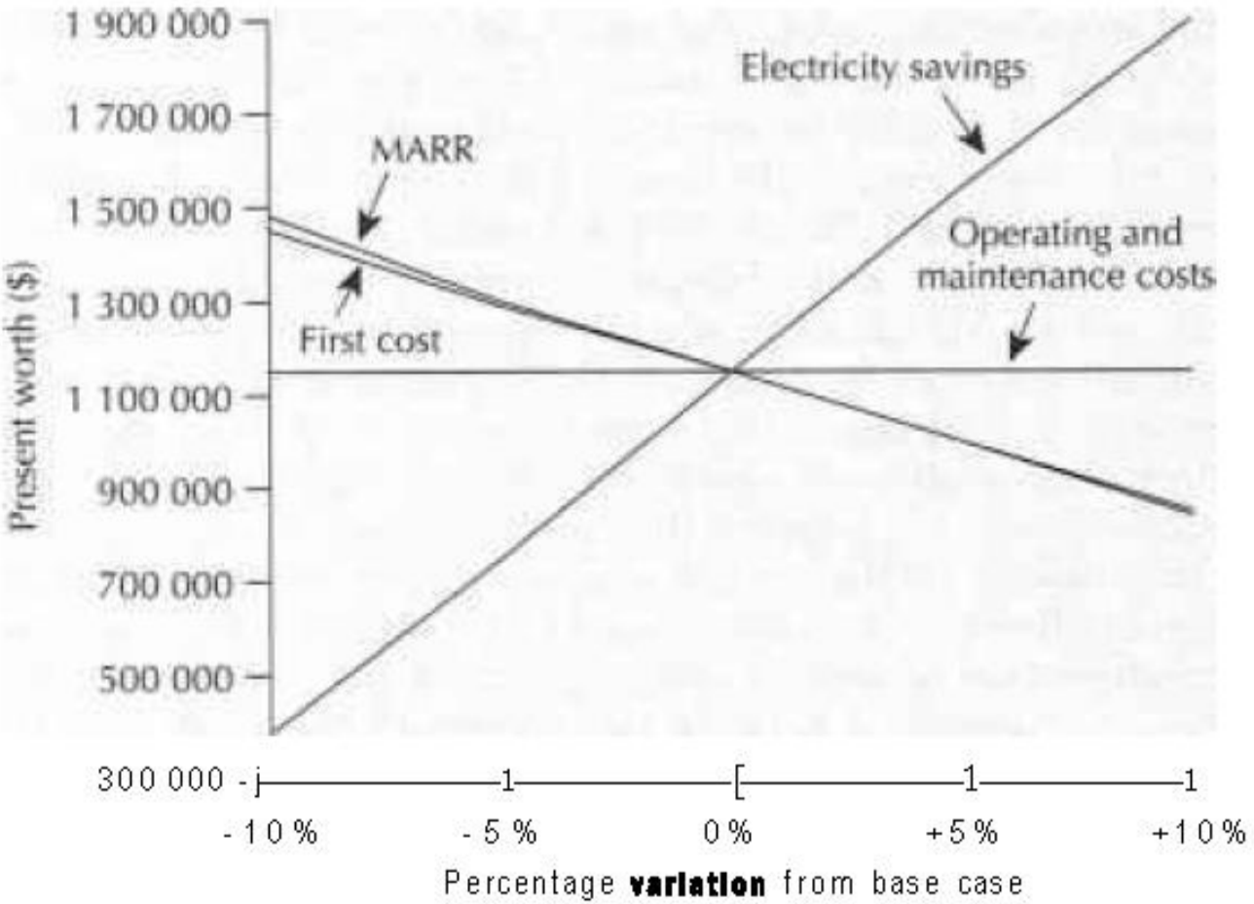

## Breakeven Analysis

* Determines the conditions under which two alternatives are equivalent
* Sensitivity analysis and breakeven analysis are commonly used in **Stage Construction** engineering problems
  + Should a facility be constructed now in its entirety, or in stages as need for increased capacity arises?
* Breakeven analysis can determine what range of parameters results in a viable project (i.e. $PW>0$) and/or what parameter values make the project break even (i.e. $PW=0$)
  + Single project: how changes in parameter values affect whether or not the project should be undertaken
  + Multiple independent projects: how changes in parameter values affect which project should be chosen
  + Mutually exclusive projects: how the projects relate to one another when parameters change

From the previous example, the breakeven chart for MARR:

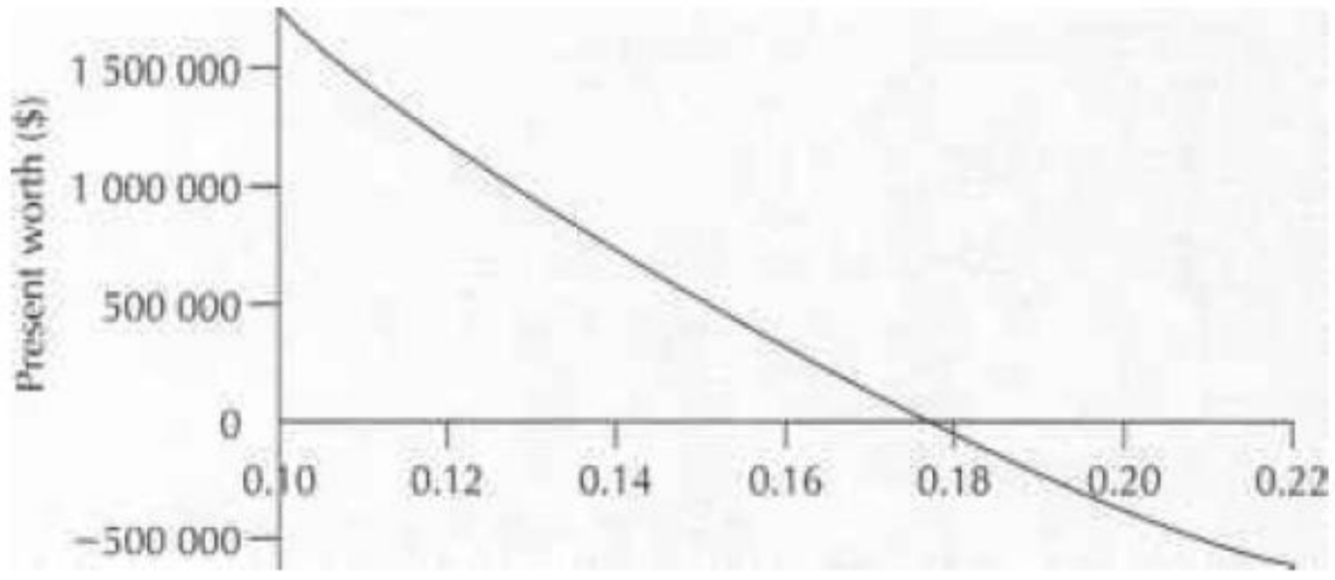

* The breakeven MARR is 17.73%
  + For MARR > 17.73%, PW > 0
  + For MARR < 17.73%, PW < 0

Example: Westmount Waxworks would like to carry out a break-even analysis on the sales volume and on the "other costs" of the Simplicity wax melter.

* What is the preferred supplier if the sales vary from 30,000 per year to 200,000 per year?
* What is the preferred supplier if the "other costs" per unit for the Simplicity model are as low as $0.45 per unit or as high as $0.75 per unit?

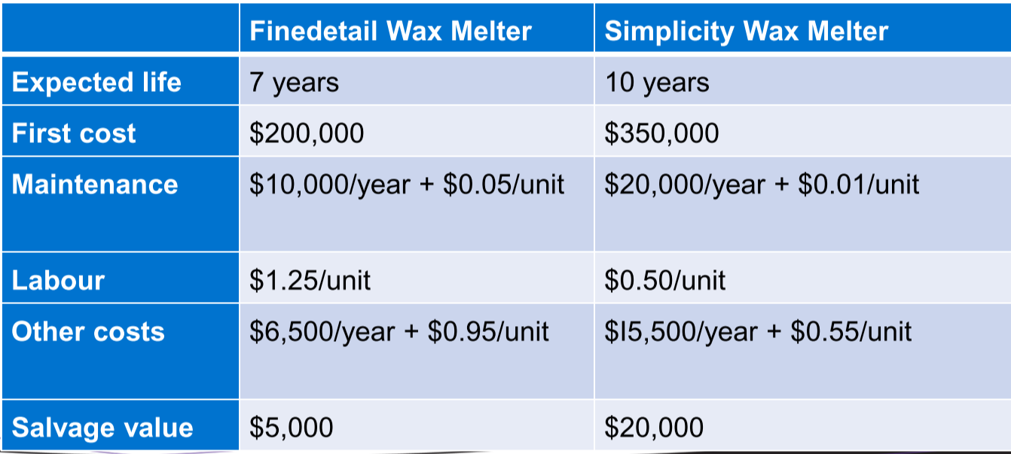

Westmount Waxworks uses an after-tax MARR of 15% for equipment projects. They pay taxes in Canada with a tax rate $t$ of 40%. The CCA rate $d$ for such equipment is 30%. (CAA is the Capital Cost Allowance: A yearly deduction or depreciation that can be claimed for income tax purposes on the cost of certain assets. CCA is generally calculated based on the declining balance method.)

**Base case (60,000 sales)**:

Finedetail:

CSF (special first-year tax benefit factor):

$$CSF=1-\frac{td}{1-d}=1-\frac{\left(0.4\right)\left(0.3\right)}{1-0.3}=0.73333$$

CTF (tax benefit factor):

$$CTF=1-\frac{td\left(1+\frac{i}{2}\right)}{\left(i+d\right)\left(1+i\right)}=1-\frac{\left(0.4\right)\left(0.3\right)\left(1+\frac{0.15}{2}\right)}{\left(i+0.3\right)\left(1+0.15\right)}=0.75073$$

$$AW=CTF(200,000)(A/P,15\%,7)-CSF(5,000)(A/F,15\%,7)+(1-t)[10,000+6,500+\left(0.05+0.95+1.25\right)\left(number of units sold\right)] \\ =\left(0.75073\right)\left(200,000\right)\left(0.24036\right)-0.73333\left(5,000\right)\left(0.09036\right)+(0.6)(16,500+2.25\left(60,000\right)) \\ =126,658$$

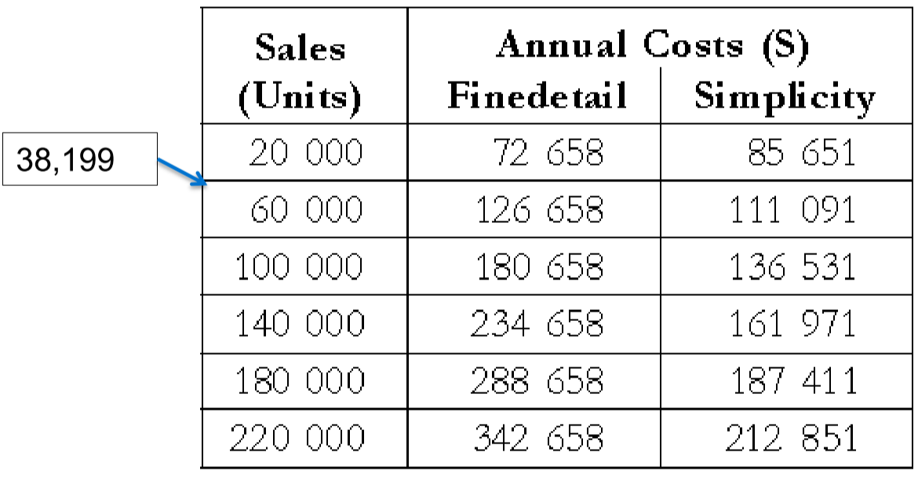

* Bellow 38,199 sales, Finedetail has lower cost
* Above 38,199 sales, Simplicity has lower cost

Example: Three mutually exclusive alternatives. Life = 20 years. Salvage value = 0. Assume MARR = 6%.

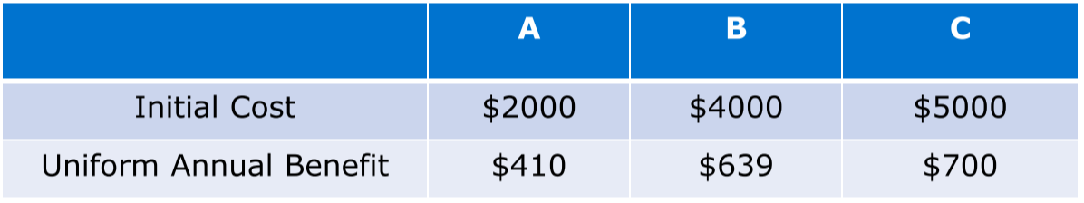

$$NPW_{A}=-2000+410(P/A,6\%,20)=2703$$

$$NPW_{B}=-4000+639(P/A,6\%,20)=3329$$

$$NPW_{C}=-5000+700(P/A,6\%,20)=3029$$

Now, we would like to know how sensitive the decision is to the estimate of the initial cost of B. If B was preferred at an initial cost of $4000, then it will continue to be preferred for any smaller values. How much higher can the initial cost go up and still have B as the preferred alternative?

$$639(P/A,6\%,20)=7329 \\ 7329-3029=4300$$

* Hence, B is the best choice if its initial cost doesn’t exceed $4300

Example: You are considering the purchase of a new equipment but there are some uncertainties about which model to buy and the expected cash flows.

Investigate the NPV of a generic system over a range of +40% with respect to (a) capital investment (b) revenues (c) salvage value (d) useful life. Given the following data:

* Capital investment = -$11,500
* Annual revenues = $5000
* Annual expenses = -$2000
* Estimated salvage value = $1000
* Useful life = 6 years
* MARR = 10%

**Base case**:

$$NPW=-11,500+\left(5,000-2,000\right)\left(P/A,10\%,6\right)+1,000(P/F,10\%,6) \\ =2,130$$

Capital investment varying by $±p\%$ function:

$$NPW\left(p\right)=-11,500\left(1+\frac{p}{100}\right)+\left(5,000-2,000\right)\left(P/A,10\%,6\right)+1,000(P/F,10\%,6)$$

Revenues varying by $±p\%$ function:

$$NPW(p)=-11,500+\left(5,000\left(1+\frac{p}{100}\right)-2,000\right)\left(P/A,10\%,6\right)+1,000(P/F,10\%,6)$$

Salvage value varying by $±p\%$ function:

$$NPW(p)=-11,500+\left(5,000-2,000\right)\left(P/A,10\%,6\right)+1,000\left(1+\frac{p}{100}\right)(P/F,10\%,6)$$

Useful life varying by $±p\%$ function:

$$l=6×\left(1+\frac{p}{100}\right)$$

$$NPW=-11,500+\left(5,000-2,000\right)\left(P/A,10\%,l\right)+1,000\left(1+\frac{p}{100}\right)(P/F,10\%,l)$$

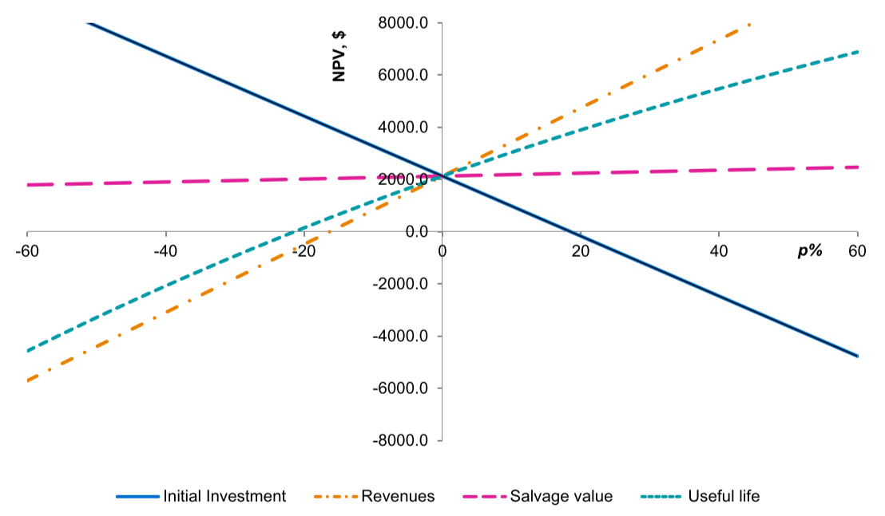

# Basic Probability and Risk-Benefit Analysis

## Probability

* Probabilities can be based on past data, expert judgement, or some combination of both
  + 0 = no chance of happening
  + 1 = will always happen
  + 0.5 = will happen half the time
* **Random variable**: parameter or variable that can take on a number of outcomes
  + Only one outcome will occur, but which one will occur is unknown at time of decision-making
* **Probability distribution function $p(x)$** : a set of numerical measures $p(x_{i})$ such that: $0≤p\left(x_{i}\right)≤1 for all i$ $$\sum_{i=1}^{m}{p(x_{i})}=1$$
* For two independent events, $p\left(A and B\right)=p\left(A\right)p(B)$
* Expected Value: each outcome is weighed by its probability, and the result is summed $$E\left(X\right)=\sum_{i=1}^{m}{x_{i} p(x_{i})}$$

Example: Find the expected cost for each product.

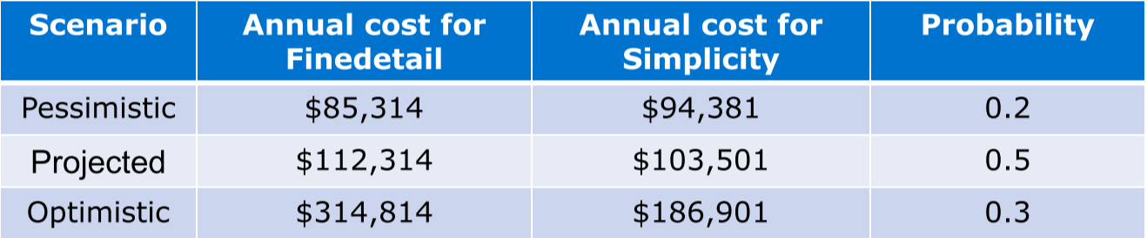

$$E\left(Finedetail,annual cost\right)=\$85,314×0.2+\$112,314×0.5+\$314,814×0.3=\$167,664$$

$$E\left(Simplicity,annual cost\right)=\$94,381×0.2+\$103,501×0.5+\$186,901×0.3=\$126,697$$

The expected annual cost of Simplicity is lower than Finedetail.

Example: The most likely value of the annual benefit from a project is $8,000 with a probability of 0.6. There is a 30% probability that it will be $5,000, and the highest value that is likely, is $10,000.

A life of 6 years is twice as likely, as a life of 9 years. The project first cost is $25,000, MARR = 10%.

* Determine the probability distributions for annual benefit and life of the project.
* Assume that the probability distribution for annual benefit and life are statistically independent, find the probability distribution of the PW.
* Determine the expected PW.

Probability distributions:

* Annual benefit:
  + $8,000 – 0.6
  + $5,000 – 0.3
  + $10,000 – 0.1
* Life:
  + 6 years – 0.67
  + 9 years – 0.33

$$PW\left(a,l\right)=-\$25,000+a(P/A,10\%,l)$$

|  |  |  |  |
| --- | --- | --- | --- |
| **Annual benefit** | **Life** | **Probability** | **PW** |
| $8,000 | 6 | $$0.6×0.667=0.40$$ | $$\$9,842$$ |
| $8,000 | 9 | $$0.6×0.333=0.20$$ | $$\$21,072$$ |
| $5,000 | 6 | $$0.3×0.667=0.20$$ | $$-\$3,224$$ |
| $5,000 | 9 | $$0.3×0.333=0.10$$ | $$\$3,795$$ |
| $10,000 | 6 | $$0.1×0.667=0.0667$$ | $$\$18,553$$ |
| $10,000 | 9 | $$0.1×0.333=0.0333$$ | $$\$32,590$$ |

$$E\left(PW\right)=\$9,842×0.40+\$21,072×0.20-\$3,224×0.20+\$3,795×0.10+\$18,553×0.067+\$32,590×0.033 \\ =\$10,204$$

* We can expect that the PW will be at most equal to or less than the expected PW (of $10,204) with a probability of 0.5.

To find the expected value of the PW, first find the expected values of the annual benefit and life:

$$E\left(Benefit\right)=\$8,000×0.40+\$5,000×0.30-\$10,000×0.10=\$3,700$$

$$E\left(Life\right)=6 years×0.67+9 years×0.33=7 years$$

$$E\left(PW\right)=-\$25,000+\$3,700(P/A,10\%,7) \\ =\$10,536$$

## Risk

* The chance of getting an outcome other than the expected value
* Commonly measured by:
  + Probability of loss
  + Standard deviation $(σ)$– square root of the variance; measures the dispersion of outcomes about the expected value $$σ=\sqrt{{\left[EV\left(X-mean\right)\right]}^{2}} \\ =\sqrt{EV\left(X^{2}\right)-{[EV(X)]}^{2}} \\ =\sqrt{x_{1}^{ 2}p\left(x_{1}\right)+x_{2}^{ 2}p\left(x_{2}\right)+x_{m}^{ 2}p\left(x_{m}\right)+…-{(EV)}^{2}}$$ 
    - The larger the difference between the mean and the values, the larger the standard deviation and variance

Example:

|  |  |  |  |  |  |
| --- | --- | --- | --- | --- | --- |
| **Annual benefit** | **Life** | **Probability** | **PW** | **Probability x PW** | **Probability x PW2** |
| $8,000 | 6 |  |  |  |  |
| $8,000 | 9 | $$0.20$$ | $$\$21,072$$ | $$\$4,214.40$$ | $$\$88,805,837$$ |
| $5,000 | 6 | $$0.20$$ | $$-\$3,224$$ | $$-\$644.80$$ | $$\$2,078,835$$ |
| $5,000 | 9 | $$0.10$$ | $$\$3,795$$ | $$\$379.50$$ | $$\$1,440,202$$ |
| $10,000 | 6 | $$0.0667$$ | $$\$18,553$$ | $$\$1,237.49$$ | $$\$22,062,325$$ |
| $10,000 | 9 | $$0.0333$$ | $$\$32,590$$ | $$\$1,085.25$$ | $$\$35,368,200$$ |
| **Total** |  | 1 |  | $$\$10,209$$ | $$\$189,398,120$$ |

$$σ=\sqrt{\$189,398,120-{\left(\$10,209\right)}^{2}}=\$9,229$$

# Project Screening and Selection: Decision Trees

## Decision Tree Analysis

* Graphical tool that describes:
  + Actions available to decision-maker
  + Events that can occur
  + Relationship between actions and events
* **Decision trees** depicts analysis of problems that involve sequential decisions and variable outcomes over time

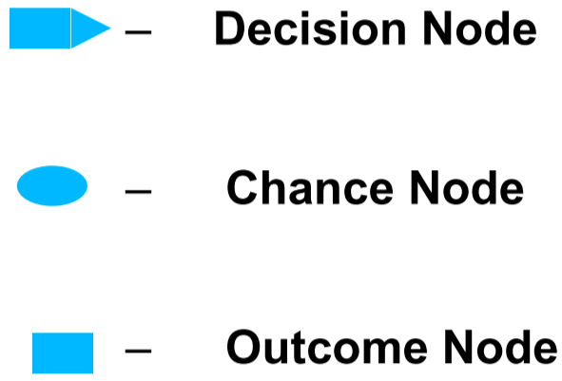

* + Decision-maker selects one alternative course of action from a finite set of possibilities
  + Each alternative is shown as a branch, with its associated cost
  + Each branch may end at an outcome node, chance node, or another decision node



* + A random event, one of a finite number of states, is expected
  + Each state is shown as a branch, with its associated probability



* + Each outcome is shown as a branch

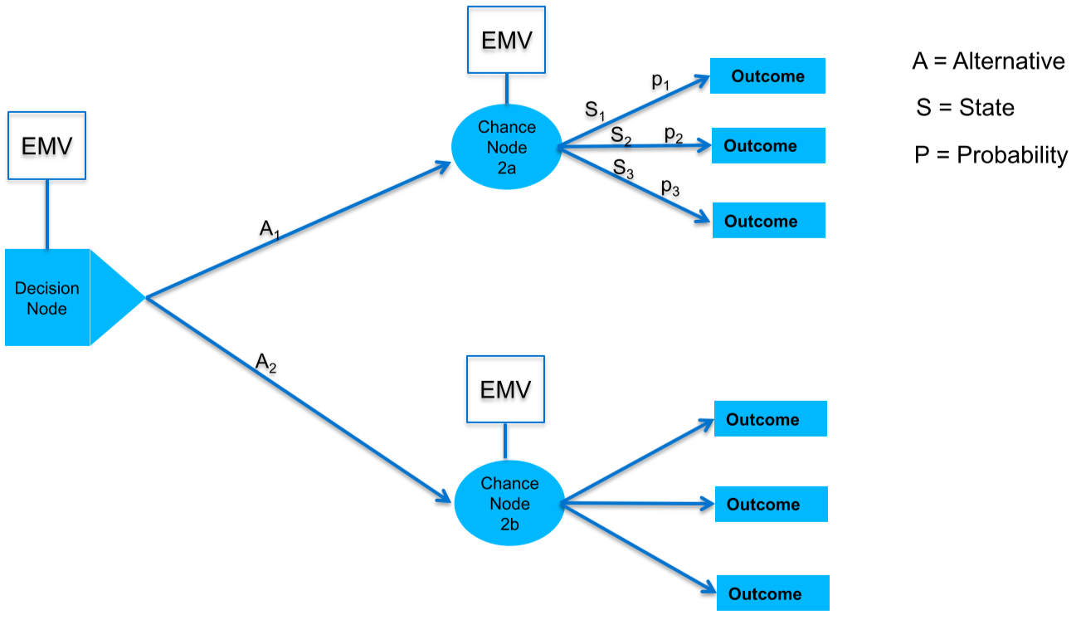

* When a **chance node follows a decision node**, it implies that the decision-maker must anticipate the outcome of future uncertain events in the decision-making
* When a **decision node follows a chance node**, it implies that the decision should be made assuming that the particular outcome occurred

### Finding the Expected Value of a Particular Decision

* 1. Develop a decision tree to represent the problem
  2. Execute the rollback procedure:
  + At each **chance node**, compute the expected value of the possible outcomes
  + The result is the expected value of the node and its branch to the left
  + At each **decision node**, select the best expected value
  + For options not selected, terminate them with a double-slash (//) on the branch
  + Continue rolling back until leftmost node
  1. The expected value of the final node is the EV of the overall decision

Example:

Edwin Electronics (EE) has a factory for assembling TVs. One of the key components is the TV screen. Recently, EE's industrial engineering team asked if they should continue outsourcing the TV screens or produce them in-house. They realized that it was important to consider the uncertainty in demand for the company's TVs.

If the future demand is low, outsourcing seems to be the reasonable option in order to save production costs. On the other hand, if the demand is high, then it may be worthwhile to produce the screens onsite, thus getting economies of scale. EE's engineers analyzed the effect of the demand uncertainty in their decision making.

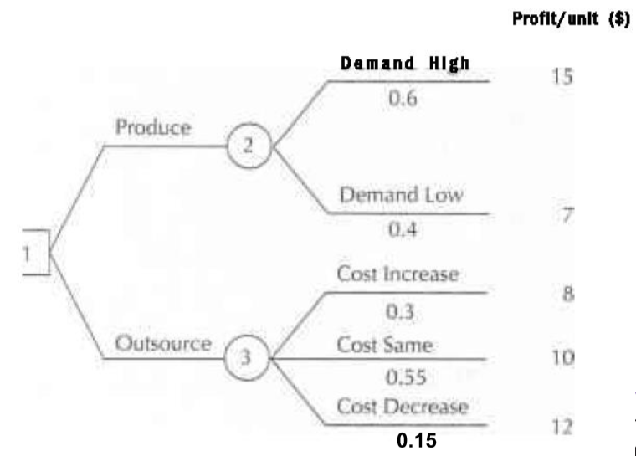



$$EV\left(2\right)=15×0.6+7×0.4=11.80$$

$$EV\left(3\right)=8×0.3+10×0.55+12×0.15=9.70$$

$$EV\left(1\right)=\max\left(11.80, 9.70\right)=11.80$$

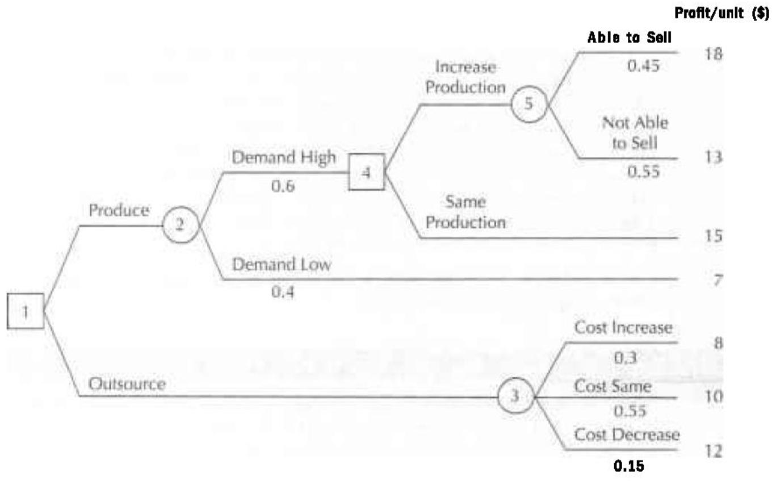



$$EV\left(5\right)=18×0.45+13×0.55=15.25$$

$$EV\left(4\right)=\max\left(15.25, 15\right)=15.25$$

$$EV\left(3\right)=8×0.3+10×0.55+12×0.15=9.70$$

$$EV\left(2\right)=15.25×0.6+7×0.4=11.95$$

$$EV\left(1\right)=\max\left(11.95,9.70\right)=11.95$$

Example:

x

$$EV\left(5\right)=60×0.5-20×0.5=20$$

$$EV\left(6\right)=40×0.2+10×0.8=16$$

$$EV\left(3\right)=\max\left(20,16\right)=20$$

$$EV\left(4\right)=\max\left(30,100\right)=100$$

$$EV\left(2\right)=20×0.7+100×0.3=44$$

$$EV\left(1\right)=\max\left(0,44\right)=44$$